3.4 - Labs (6)

* **Lab 3.4.7 (1) Old problems - new methods: functions [B]**

bool isLeap(unsigned int year)

{

if (year % 400 == 0)

return true;

if (year % 4 == 0)

return true;

return false;

}

#include <iostream>

using namespace std;

int main()

{

for (int yer = 1995; yer < 2020; yer++)

cout << yer << " -> " << isLeap(yer) << endl;

return 0;

}

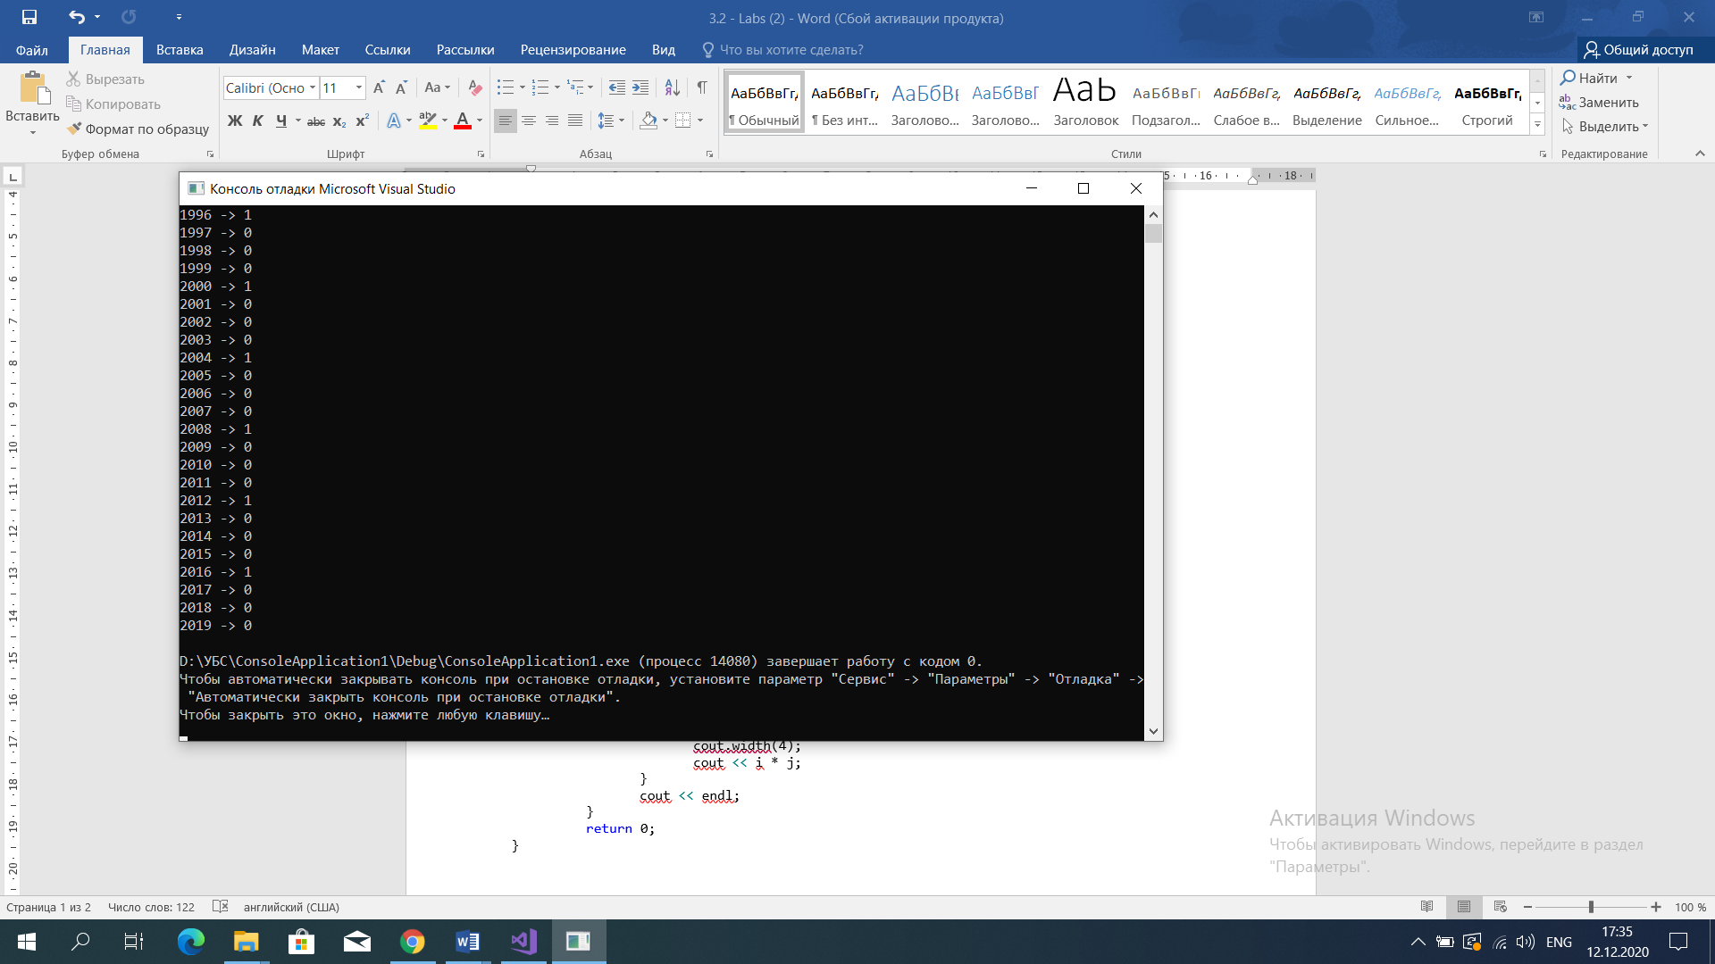

* **Lab 3.4.7 (2) One step further: finding length of months [B]**

#include <iostream>

using namespace std;

bool isLeap(int year)

{

if (year % 400 == 0)

return true;

if (year % 4 == 0)

return true;

return false;

}

unsigned int monthLength_noCout(int year, int month)

{

switch (month)

{

case 1:

{

return 31;

break;

}

case 2:

{

if (isLeap(year) == true)

return 29;

else

return 28;

break;

}

case 3:

{

return 31;

break;

}

case 4:

{

return 30;

break;

}

case 5:

{

return 31;

break;

}

case 6:

{

return 30;

break;

}

case 7:

{

return 31;

break;

}

case 8:

{

return 31;

break;

}

case 9:

{

return 30;

break;

}

case 10:

{

return 31;

break;

}

case 11:

{

return 30;

break;

}

case 12:

{

return 31;

break;

}

default:

break;

}

return 0;

}

int main()

{

for (int yr = 2000; yr < 2002; yr++)

{

cout << "---------------------" << endl;

cout << "YEAR : " << yr << endl;

for (unsigned int mo = 1; mo <= 12; mo++)

cout << mo << " - " << monthLength_noCout(yr, mo) << endl;

}

return 0;}

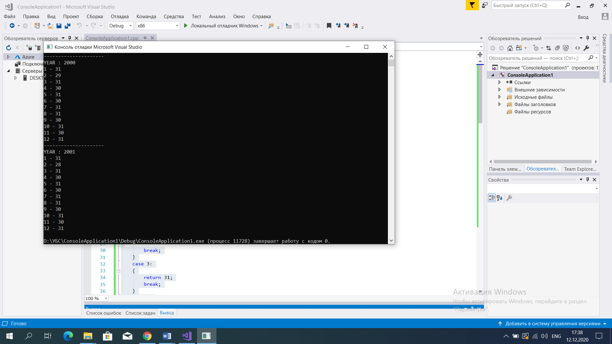

* **Lab 3.4.7 (3) Second step further: finding day of year [B]**

#include <iostream>

using namespace std;

struct Date

{

int year;

int month;

int day;

};

bool isLeap(int year)

{

if (year % 400 == 0)

return true;

if (year % 4 == 0)

return true;

return false;

}

int monthLength(int year, int month)

{

switch (month)

{

case 1:

{

return 31;

break;

}

case 2:

{

if (isLeap(year) == true)

return 29;

else

return 28;

break;

}

case 3:

{

return 31;

break;

}

case 4:

{

return 30;

break;

}

case 5:

{

return 31;

break;

}

case 6:

{

return 30;

break;

}

case 7:

{

return 31;

break;

}

case 8:

{

return 31;

break;

}

case 9:

{

return 30;

break;

}

case 10:

{

return 31;

break;

}

case 11:

{

return 30;

break;

}

case 12:

{

return 31;

break;

}

default:

break;

}

return 0;

}

int dayOfYear(Date date)

{

int count = 0;

for (int mo = 0; mo <= date.month - 1; mo++)

count += monthLength(date.year, mo);

count += date.day;

return count;

}

int main()

{

Date d;

cout << "Enter year, month and day:" << endl;

cin >> d.year >> d.month >> d.day;

cout << "It is " << dayOfYear(d) << " day of the year" << endl;

return 0;

}

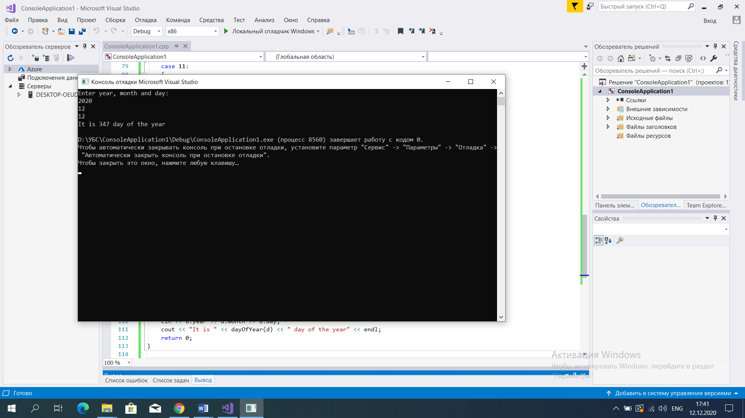

* **Lab 3.4.7 (4) Third step further - counting days [B]**

#include <iostream>

using namespace std;

struct Date

{

int year;

int month;

int day;

};

bool isLeap(unsigned int year)

{

if (year % 400 == 0)

return true;

if (year % 4 == 0)

return true;

return false;

}

unsigned int monthLength_noCout(int year, int month)

{

switch (month)

{

case 1:

{

return 31;

break;

}

case 2:

{

if (isLeap(year) == true)

return 29;

else

return 28;

break;

}

case 3:

{

return 31;

break;

}

case 4:

{

return 30;

break;

}

case 5:

{

return 31;

break;

}

case 6:

{

return 30;

break;

}

case 7:

{

return 31;

break;

}

case 8:

{

return 31;

break;

}

case 9:

{

return 30;

break;

}

case 10:

{

return 31;

break;

}

case 11:

{

return 30;

break;

}

case 12:

{

return 31;

break;

}

default:

break;

}

return 0;

}

int dayOfYear(Date date)

{

int count = 0;

for (int mo = 0; mo <= date.month - 1; mo++)

count += monthLength_noCout(date.year, mo);

count += date.day;

return count;

}

int theDiff(Date s, Date t)

{

if (dayOfYear(t) - dayOfYear(s) >= 0)

{

if (t.year > s.year)

{

int g;

g = (t.year - s.year) * 365;

return dayOfYear(t) - dayOfYear(s) + g;

}

if (t.year == s.year)

return dayOfYear(t) - dayOfYear(s);

}

else

return -1;

}

int main()

{

Date since;

Date till;

cout << "Enter the 'since' date:" << endl;

cin >> since.year >> since.month >> since.day;

cout << "Enter the 'till' date:" << endl;

cin >> till.year >> till.month >> till.day;

cout << "The difference is: " << theDiff(since, till) << " days" << endl;

return 0;

}

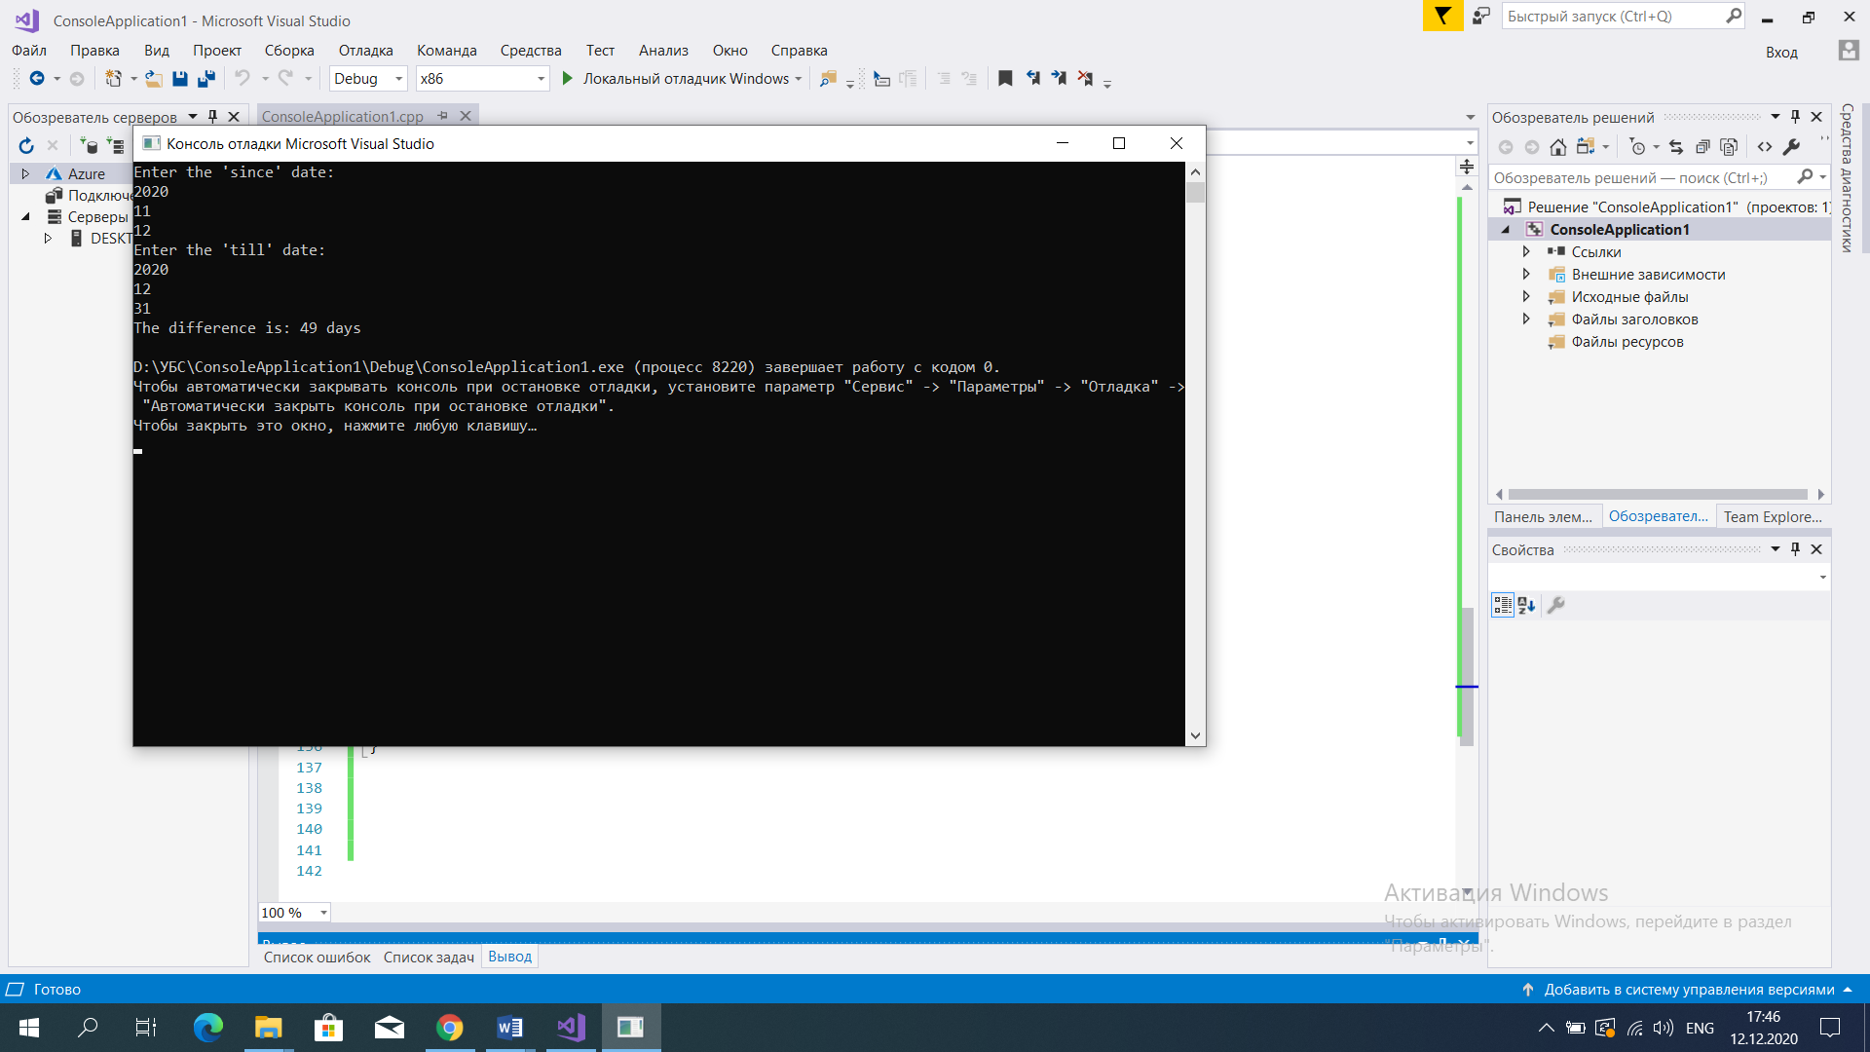

* **Lab 3.4.7 (6) Prime numbers - how to find them? [B]**

#include <iostream>

using namespace std;

bool isPrime(int num)

{

for (int i = 2; i <= num / 2; i++)

if ((num % i) == 0)

return false;

return true;

}

int main()

{

for (int i = 1; i <= 21; i++)

if (isPrime(i))

cout << i << " ";

cout << endl;

return 0;

}

